Practical-9
Secure User Registration with Database Insert, Duplicate Email Check, and Password Hashing
Theory :
- Is password_hash() used before storing passwords?
Ans: Yes. password_hash() is used to securely hash passwords before storing them in the database.
- Is duplicate email/username checked?
Ans: Yes. Duplicate email addresses and usernames are checked to prevent multiple accounts with the same credentials.
- Are frontend and backend validations consistent?
Ans: Yes. Frontend and backend validations are consistent. Both validate user inputs, while backend validation provides additional security.

Result:
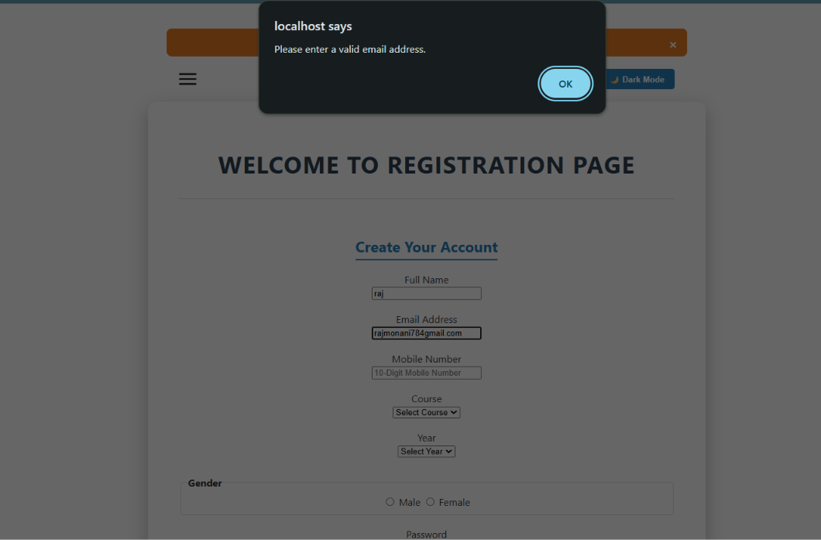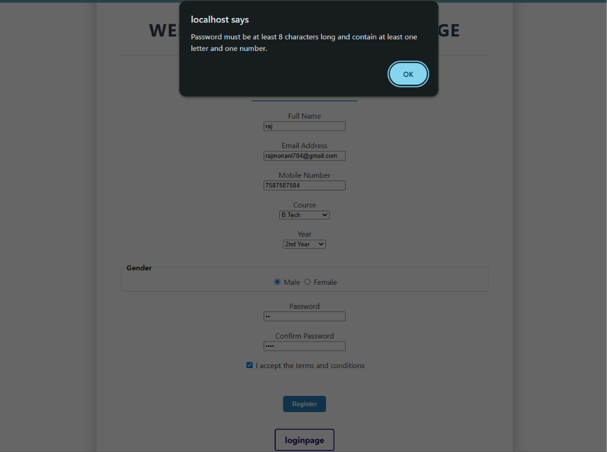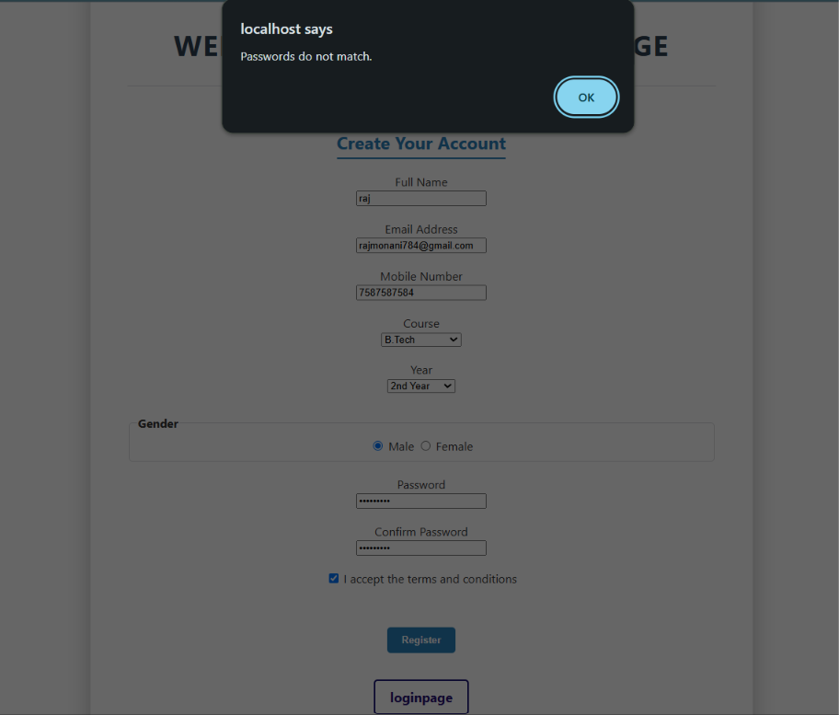

GitHub Repository Link:
https://github.com/RajMonani/Student-Portal-Hub

Challenges Faced:

During implementation, I faced challenges in validating user inputs on both the frontend and backend.I faced difficulty checking duplicate email addresses and usernames before inserting data into the database. I also faced challenges in implementing password hashing and handling database errors secure

- Learning Outcome:-

I learned how to implement secure user registration using PHP and MySQLi. I understood how to validate user inputs and check duplicate email addresses and usernames. I also learned how to hash passwords securely using password_hash() before storing them in the database.

